LSRCNA XLI MEMBER SERVICES
NEEDS YOU!!
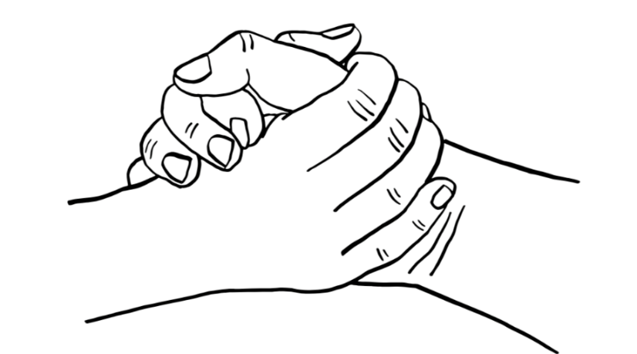

FOR VOLUNTEER OPPORTUNITIES PLEASE CONTACT
SHANNON M. 469-964-7274
TIM A. 903-306-5073
A HELPING HAND
HELPING OUT

